Code development and calculation flowsheet for finding estimate of Shell NGL Ethane, Propane and Butane flows

Abstract
To get an understanding of the products and their rough flows available to us, several assumptions were made and NSTA data was used to generate a rough model showing the likely decline of ethane, propane and butane throughput for the duration of the project.

AI Prompting/Coding
Full ChatGPT prompts used to develop model for Ethane, Propane and Butane production at Shell NGL plant:
https://chatgpt.com/share/6ab38f36-1a64-83ed-8bc9-2e344f504a65

Flowsheet
The flowsheet for the calculation is as follows: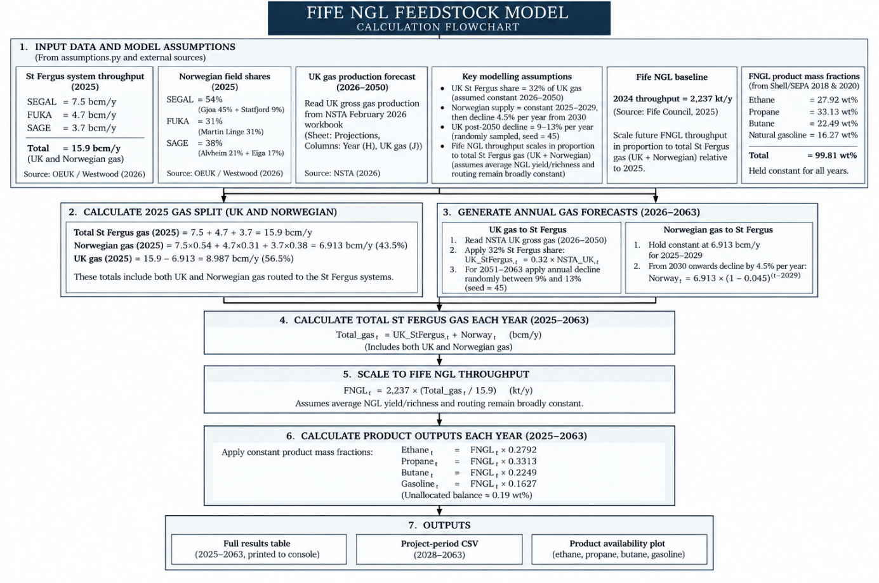
The assumptions of the calculation are detailed further in ASSUMPTIONS.txt

Results and Analysis

Raw Data
The results can be found in:
C:\Users\Joe\OneDrive - Heriot-Watt University\Uni_Cloud\Year 5\B41HE_MEng_Design\Group\North_Sea_Feedstock_Model
(To be updated with link to teams shared chat when fully finished)
Where there is data for each particular product from Shell NGL over time

Graphing
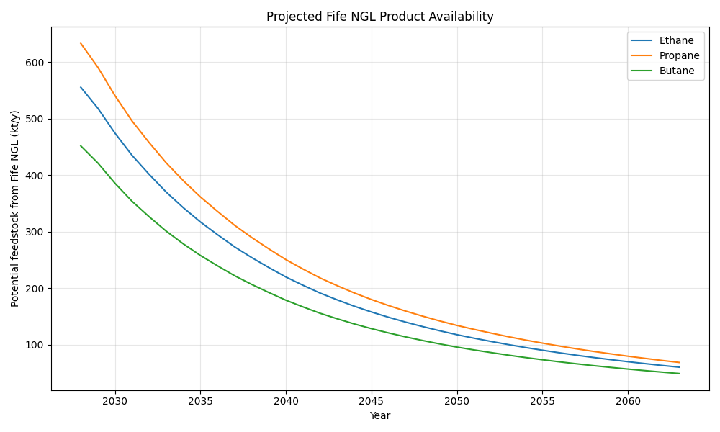
Current potential feedstock and projected decline (NSTA) & (NOD). Several assumptions were made in producing this graph.

Fife NGL Feedstock Decline Rate
To obtain a representative decline rate for the projected Fife NGL feedstock, an exponential decline curve was fitted to the projected total NGL throughput between 2028 and 2063. This allows the long-term feedstock projection to be represented using a single equation that can subsequently be incorporated into the process and economic model.
The projected feedstock data were first linearised by taking the natural logarithm of the annual feedstock throughput. A linear regression was then fitted using the following general relationship:
$$ln(Fₜ) = a + bt$$
where Fₜ is the total NGL feedstock available in year t (kt/y), t is the number of years after 2028, a is the regression intercept, and b is the fitted decline coefficient.
Regression of the projected 2028–2063 feedstock data gave:
$$ln(Fₜ) = 7.466 - 0.06304t$$
Converting this logarithmic relationship back to its exponential form gives:
$$Fₜ = 1748.2e⁻⁰·⁰⁶³⁰⁴ᵗ$$
The regression gave an R² value of approximately:
$$R² = 0.9923$$
This indicates that an exponential decline provides a very good representation of the overall projected decline in NGL feedstock over the project period.
The continuous decline coefficient obtained from the regression is:
$$k = 0.06304 yr⁻¹$$
This can be converted into an equivalent annual compound decline rate using:
$$d = 1 - e⁻ᵏ$$
Substituting the fitted decline coefficient:
$$d = 1 - e^{-0.0634}$$
which gives:
$$d = 0.0611$$
Therefore, the equivalent annual compound decline rate is approximately:
$$d = 6.11\% per year$$
The feedstock available in any future year can therefore be approximated using:
$$Fₜ = F₀(1 - d)ᵗ$$
Substituting the calculated annual decline rate gives:
$$Fₜ = F₀(1 - 0.0611)ᵗ$$
and therefore:
$$Fₜ = F_{0}\left(0.9389\right)ᵗ$$
where F₀ is the feedstock available in the selected base year and t is the number of years after that base year.
The 6.11% per year decline rate represents a single average exponential decline across the full 2028–2063 projection period. The actual year-to-year decline in the underlying feedstock projection is not constant because the UK and Norwegian contributions to the Fife NGL system follow different decline profiles. However, the high R² value of 0.9923 demonstrates that the exponential relationship provides a suitable simplified representation of the overall long-term trend.
For subsequent process modelling, the relationship can therefore be used to reduce the available feedstock annually over the operating life of the proposed plant.

